**Some Pioneers in Indian Neurology**

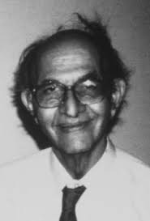

Dr. Eddie Barucha

First practicing clinical neurologist in Bombay (1951)

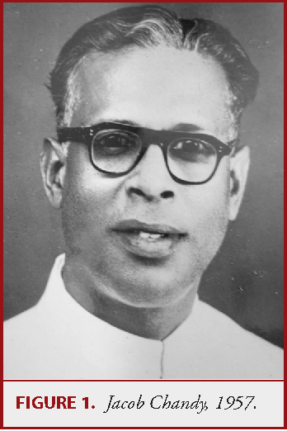

Dr. Chandy

Helped start the first Department of Neurosurgery in India

One of the founding members of the Neurological Society of India (NSI)

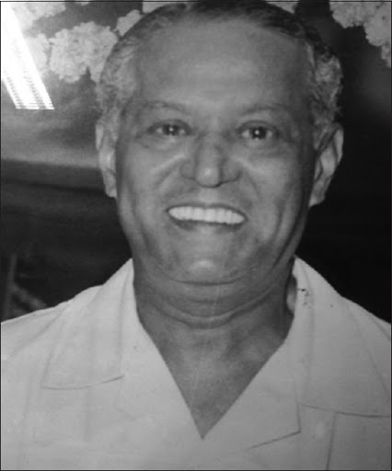

Dr. Ram Ginde

Started the third Department of Neurosurgery in India at Seth GS Medical College, Mumbai (1951)

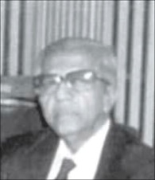

Dr. T. K. Gosh

Second President of NSI

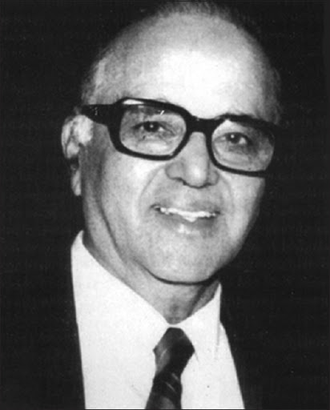

Dr. B. Ramamurthi

Credited with the creation of the Department of Neurosurgery in Madras

co-founder of the NSI

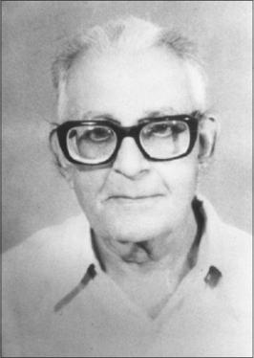

Dr. Baldev Singh

First Neuroscience professor in India

Instrumental in the formation of NSI

Led the Department of Neurology at All India Institute of Medical Sciences in 1965

Considered the father of Indian neurology

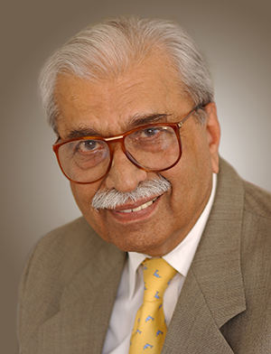

Dr. Noshir Wadia

Created and led the Department of Neurology at Grant Medical College in the 1960s

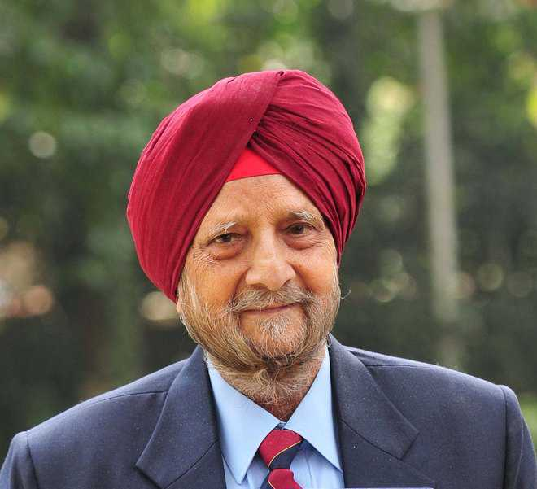

Dr. Chopra

Founder of Indian Academy of Neurology in 1991